|  |  |  |  |  |
| --- | --- | --- | --- | --- |
| **National University of Computer and Emerging Sciences, Lahore Campus** | | | | |
| C:\Users\saif\AppData\Local\Microsoft\Windows\Temporary Internet Files\Content.Word\final design.jpg | **Course:** | **Database Systems** | **Course Code:** | **CS219** |
| **Program:** | **BS(Computer Science)** |  |  |
|  |  |  |  |
|  |  |  |  |
|  |  |  |  |
| **Practice Problem:** | **Relational Model (3) - SOLUTION** |  |  |

**Question 1:**

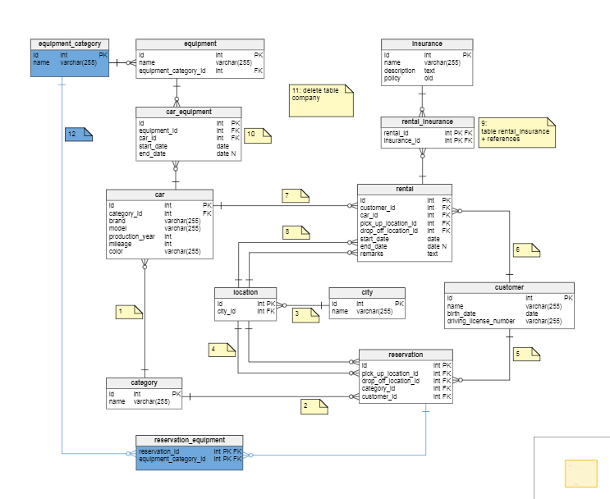

**Question 3:**

**R**

|  |  |  |  |  |
| --- | --- | --- | --- | --- |
| A | B | C | D | E |

S

|  |  |  |  |
| --- | --- | --- | --- |
| F | G | H | I |

**T**

|  |  |  |  |
| --- | --- | --- | --- |
| A | F | H | I |

1. State all the super key(s) for the above relation.

*A, B, AB, AC, AD, AE, ABC, ABD, ABE, ACD, ACE, ABCDE, BCD, BCE, BDE, BC, BD, BE*

*F, FG, FH, FI, FGH, FGI, FHI, FGHI*

*AF, AFH, AFI, AFHI*

1. Mention the super key(s) which are minimal (i.e. key).

*A & B in R, F in S, AF in T.*

**Question 4:**

**Employee Department**

|  |  |  |  |
| --- | --- | --- | --- |
| **ID** | **Name** | **Salary** | **Department ID** |
| 1 | Tom | 15000 | 1 |
| 2 | Pam | 20000 | 3 |
| 3 | John | 50000 | 2 |
| 4 | Sam | 60000 | 3 |
| 5 | Todd | 70000 | 2 |
| 6 | Neil | 10000 | NULL |

|  |  |  |
| --- | --- | --- |
| **ID** | **Department_ Name** | **Location** |
| 1 | CS | London |
| 2 | EE | NULL |
| 3 | BBA | New York |
| 4 | Other Department | Sydney |

**\*Consider all questions are Independent.**

1. **For Delete**
   1. **Assume that foreign key with cascading option is implemented.**
2. Delete the department(s) whose location is NULL

*Department EE will be deleted. All employees who are in EE department will also be deleted.*

* + 1. Delete the employee(s) whose department id is 3.

*The employees with ID 2, 4 will be deleted.*

* + 1. Delete the department having id equal to 4.

*The department having id 4 will be deleted. There will be no change in Employee Table.*

* 1. **Assume that foreign key with Set NULL option is implemented.**

1. Delete the department whose location is New York.

|  |  |  |  |
| --- | --- | --- | --- |
| **ID** | **Name** | **Salary** | **Department ID** |
| 1 | Tom | 15000 | 1 |
| 2 | Pam | 20000 | NULL |
| 3 | John | 50000 | 2 |
| 4 | Sam | 60000 | NULL |
| 5 | Todd | 70000 | 2 |
| 6 | Neil | 10000 | NULL |

|  |  |  |
| --- | --- | --- |
| **ID** | **Department_ Name** | **Location** |
| 1 | CS | London |
| 2 | EE | NULL |
| 4 | Other Department | Sydney |

|  |  |  |
| --- | --- | --- |
| **ID** | **Department_ Name** | **Location** |
| 2 | EE | NULL |
| 3 | BBA | New York |
| 4 | Other Department | Sydney |

1. Delete the department whose department name is CS

|  |  |  |  |
| --- | --- | --- | --- |
| **ID** | **Name** | **Salary** | **Department ID** |
| 1 | Tom | 15000 | NULL |
| 2 | Pam | 20000 | 3 |
| 3 | John | 50000 | 2 |
| 4 | Sam | 60000 | 3 |
| 5 | Todd | 70000 | 2 |
| 6 | Neil | 10000 | NULL |

1. Delete the employee whose id is 4.

|  |  |  |  |
| --- | --- | --- | --- |
| **ID** | **Name** | **Salary** | **Department ID** |
| 1 | Tom | 15000 | 1 |
| 2 | Pam | 20000 | 3 |
| 3 | John | 50000 | 2 |
| 5 | Todd | 70000 | 2 |
| 6 | Neil | 10000 | NULL |
|  |  |  |  |

|  |  |  |
| --- | --- | --- |
| **ID** | **Department_ Name** | **Location** |
| 1 | CS | London |
| 2 | EE | NULL |
| 3 | BBA | New York |
| 4 | Other Department | Sydney |

1. Delete all departments.

|  |  |  |  |
| --- | --- | --- | --- |
| **ID** | **Name** | **Salary** | **Department ID** |
| 1 | Tom | 15000 | NULL |
| 2 | Pam | 20000 | NULL |
| 3 | John | 50000 | NULL |
| 4 | Sam | 60000 | NULL |
| 5 | Todd | 70000 | NULL |
| 6 | Neil | 10000 | NULL |

|  |  |  |
| --- | --- | --- |
| **ID** | **Department_ Name** | **Location** |

* 1. **Assume that foreign key with no action is implemented.**

1. Delete the department whose location is New York.

*Operation not allowed since there are two employees who have this department id.*

* + 1. Delete the department having id equal to 4.

*The department will be deleted. No change in the Employee Table.*

* + 1. Delete the employee(s) having salary greater than 40000.

*All employees having salary greater than 40000 will be deleted. No change in the department table.*

1. **For Insert**

**a. Assume that foreign key with cascading option is implemented.**

1. Insert <NULL, ‘Physics’, ‘Tokyo’> into Department.

*Operation not allowed since the primary key cannot be null.*

* + 1. Insert <7, ‘George’, 54000, 6>into Employee.

*Operation not allowed since referential integrity constraint is being violated.*

* + 1. Insert <8, ‘John’, 60000 > into Employee.

*Operation will be allowed. The department id of the employee will be set to NULL. NO change in the department table.*

* 1. **Assume that foreign key with set NULL is implemented.**

1. Insert <4, ‘Ali’, 100000, 2> into Employee.

*Operation not allowed because primary key constraint is being violated.*

* + 1. Insert <NULL, ‘Hameed’, 80000,1> into Employee.

*Operation not allowed since primary cannot be NULL.*

* + 1. Insert <5, ‘Physics’, ‘Karachi’ > into Department.

*The department will be inserted. No change in the employee table.*

* + 1. Insert < ’7’ , ‘Mathematics’, ‘Sydney’> into Department.

*Operation allowed. Character type will be converted to integer by sql.*

* 1. **Assume that foreign key with No Action is implemented.**

1. Insert <7, ‘Ali’, 40000> into Employee.

*Operation allowed. The department id of this employee will be set to NULL.*

* + 1. Insert <10, ‘Umer’, 60000, 6> into Employee.

*Operation not allowed since referential integrity constraint is being violated.*

* + 1. Insert <3, ‘Physics’, ‘New York’, 1>

*Operation not allowed since primary key constraint is being violated.*

1. **For Update**
   1. **Assume that foreign key with cascading option is implemented**
2. For the department having id=4, change the id to 3.

*Operation not allowed since primary key constraint is being violated.*

* + 1. For the department having id=1, change the location to Karachi.

*The location of department will be changed from Sydney to Karachi. No change in the employee table.*

* + 1. For the employee having id=1, change the id to 8.

*The id of the employee will be changed from 1 to 8. No change in the department table.*

* + 1. For the department having id=3, change the id to 10.

|  |  |  |  |
| --- | --- | --- | --- |
| **ID** | **Name** | **Salary** | **Department ID** |
| 1 | Tom | 15000 | 1 |
| 2 | Pam | 20000 | 10 |
| 3 | John | 50000 | 2 |
| 4 | Sam | 60000 | 10 |
| 5 | Todd | 70000 | 2 |
| 6 | Neil | 10000 | NULL |

|  |  |  |
| --- | --- | --- |
| **ID** | **Department_ Name** | **Location** |
| 1 | CS | London |
| 2 | EE | NULL |
| 10 | BBA | New York |
| 4 | Other Department | Sydney |

* 1. **Assume that foreign key with set NULL option is implemented.**

1. For the department having id=1, change the id to 8.

|  |  |  |  |
| --- | --- | --- | --- |
| **ID** | **Name** | **Salary** | **Department ID** |
| 1 | Tom | 15000 | NULL |
| 2 | Pam | 20000 | 3 |
| 3 | John | 50000 | 2 |
| 4 | Sam | 60000 | 3 |
| 5 | Todd | 70000 | 2 |
| 6 | Neil | 10000 | NULL |

|  |  |  |
| --- | --- | --- |
| **ID** | **Department_ Name** | **Location** |
| 8 | CS | London |
| 2 | EE | NULL |
| 3 | BBA | New York |
| 4 | Other Department | Sydney |

* + 1. For department having location as NULL, change the id to 4.

*Operation not allowed since primary key constraint is being violated.*

* + 1. For the department having name=’BBA’, change the name to ‘Mathematics’.

*The name will be changed. No change in the Employee table*.

* 1. **Assume that foreign key with no Action is implemented.**

1. For department having department name as NULL, update the department name to ‘Karachi’.

*The name will be changed. No change in the Employee table.*

* + 1. For department having department id=4, update the department id to 3.

*Operation not allowed since primary key constraint is being violated.*

* + 1. For department having department id= 1, update the department id to 10.

*Operation not allowed since there is an employee whose department id is 1.*

* + 1. For department having department id=4, update the department id to 6

. *Operation allowed. No change in the employee table.*